**Problem Statement 11**: Design a 256B RAM chip using 128B RAM chip .

**Circuit diagram:**

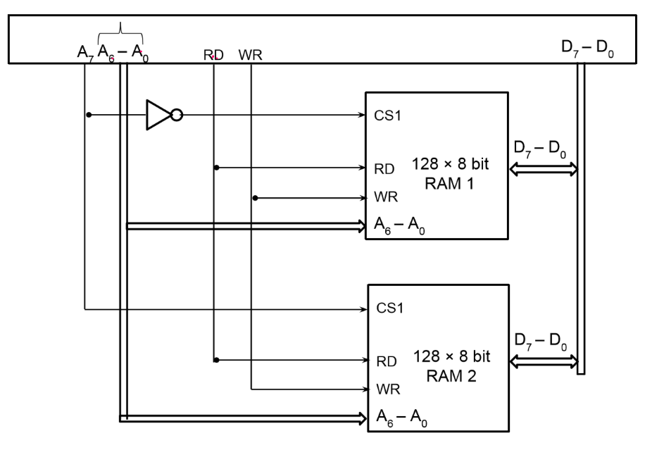

**Memory Address Map:**

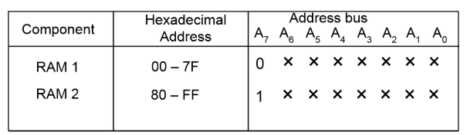

**Output:**



**Problem Statement 12**: Design a 1kB RAM chip using 256B RAM chip.

**Circuit diagram:**

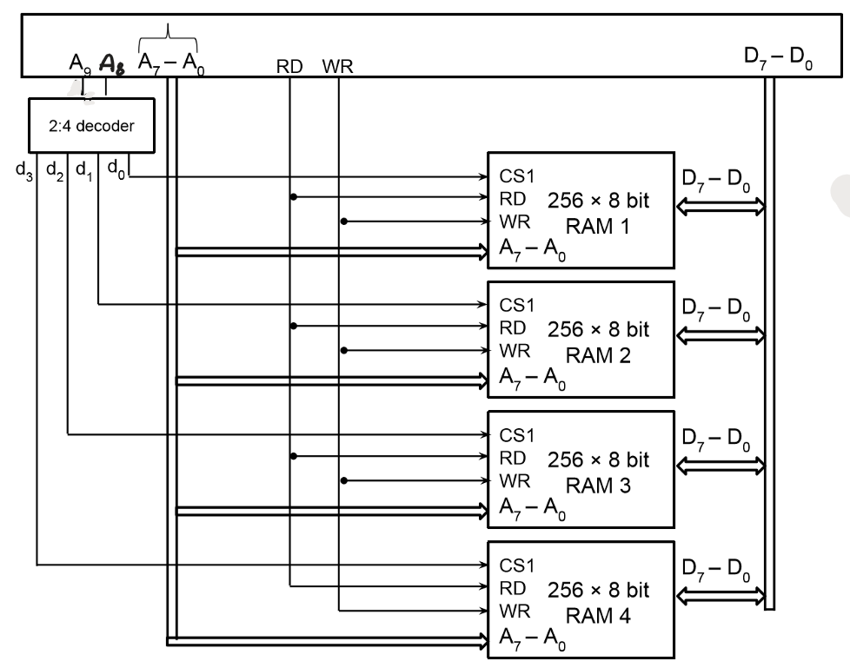

**Memory Address Map:**

**Output:**

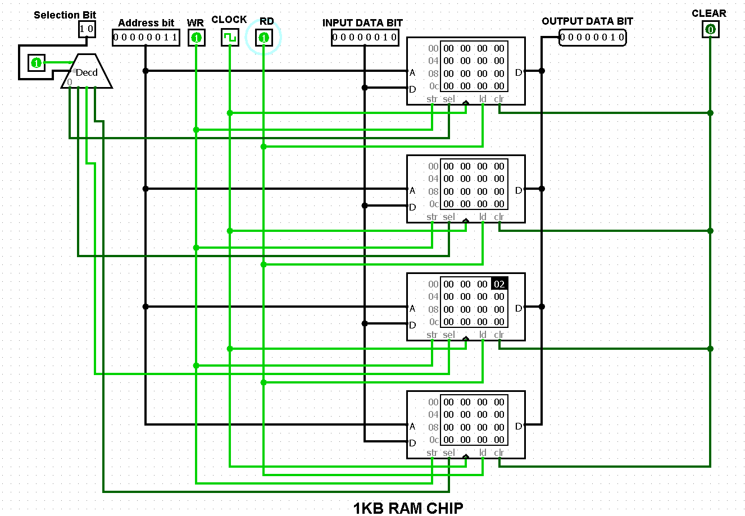

**Problem Statement 13**: Design a 1KB memory chip using 128B RAM chip and 512B ROM chip.

**Circuit diagram:**

**Memory Address Map:**

**Output:**

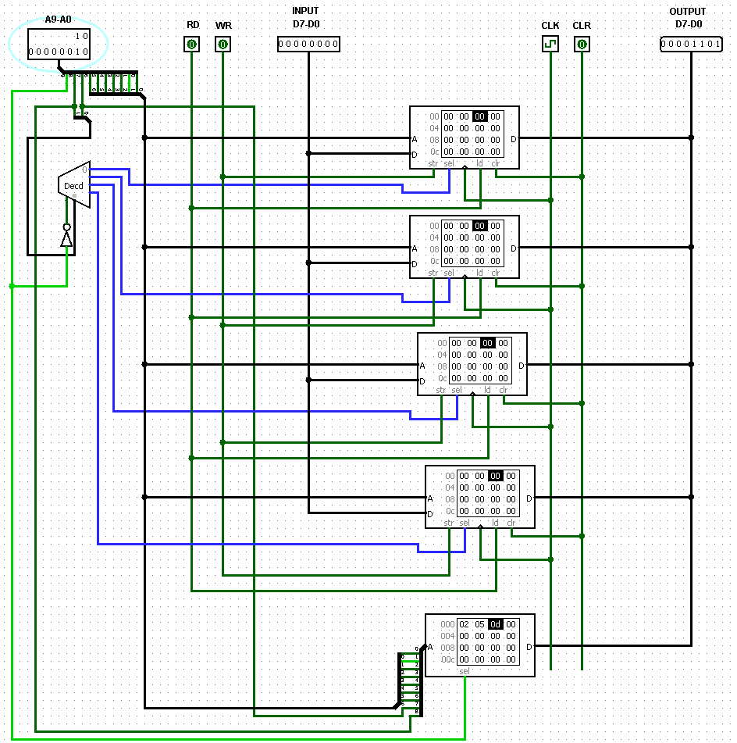

**1KB memory chip using 128B RAM chip and 512B ROM chip**

**Problem Statement 14**: Design a 512 X 16 RAM chip using 128 X 8 RAM chip.

**Circuit diagram:**

**Memory Address Map:**

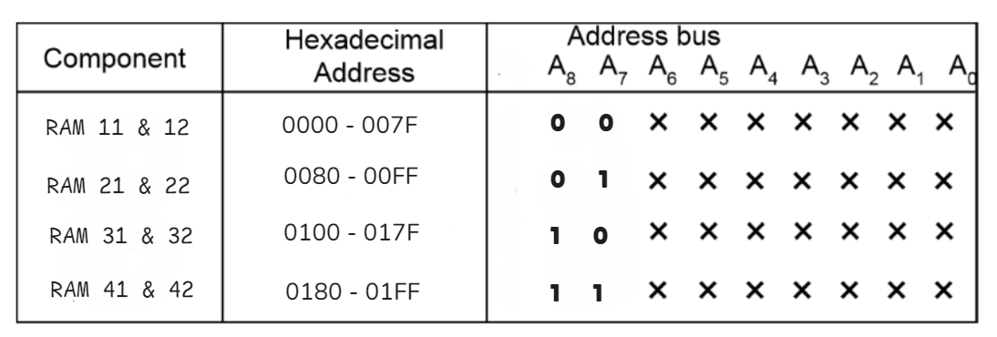

**Output:**

**512 X 16 RAM chip using 128 X 8 RAM chip**

**Problem Statement 15:** Design a 2KB RAM chip by using above mention 1KB RAM chip.

**Circuit diagram:**

**Memory Address Map:**

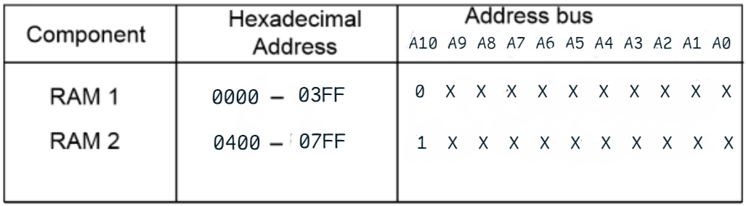

**Block Diagram of 1KB RAM chip**

**Output:**

**2KB RAM chip by using above mention 1KB RAM chip**